Roman Cassman 1-11-2023

Lab1 - Assessing the Network With Common Security Tools

Part 1:

Question 4.

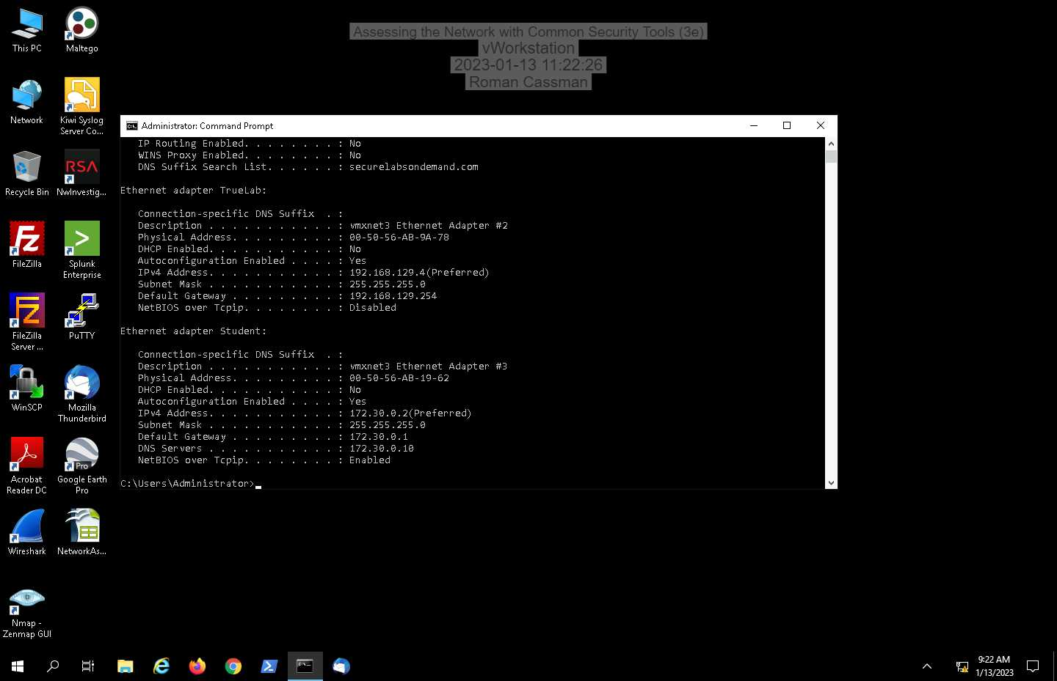

Question 7

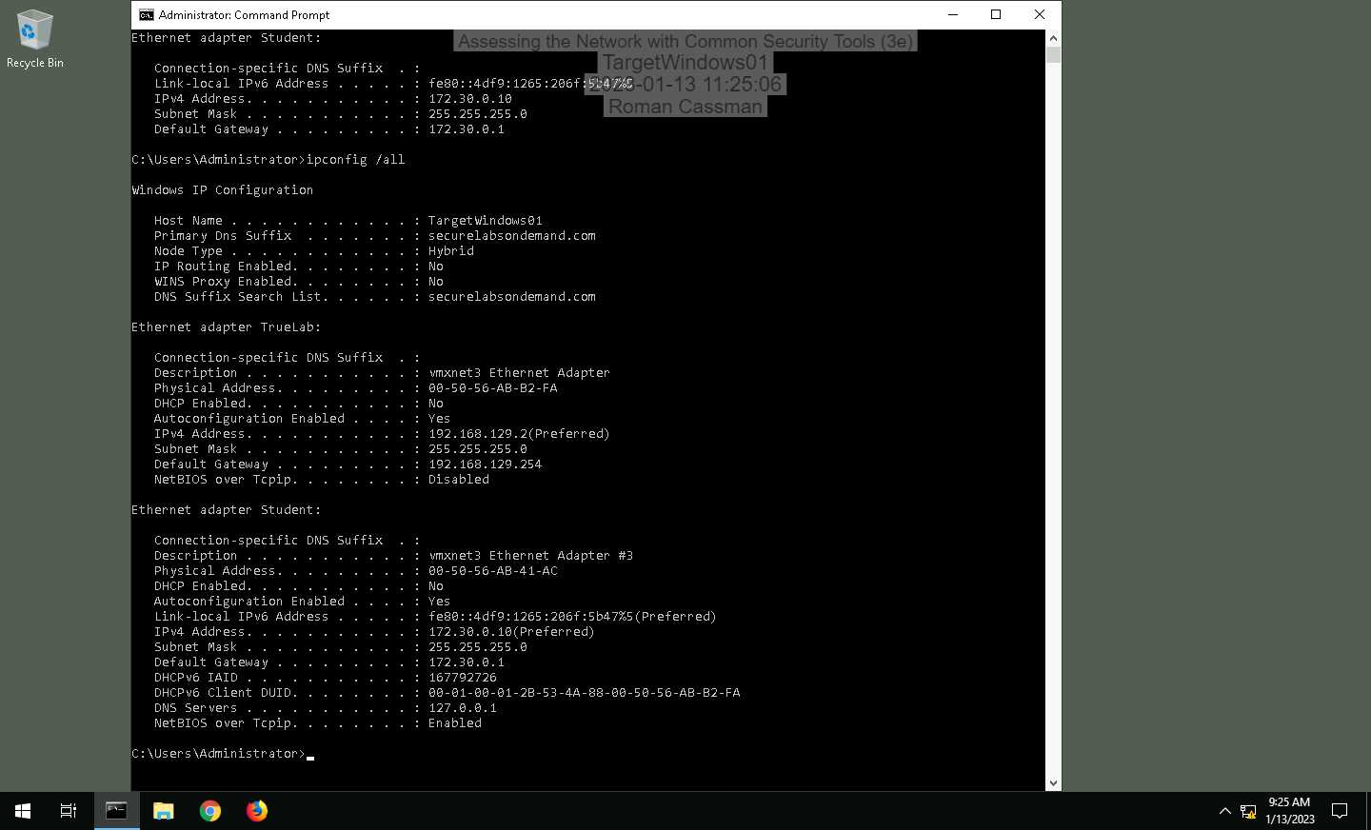

15.

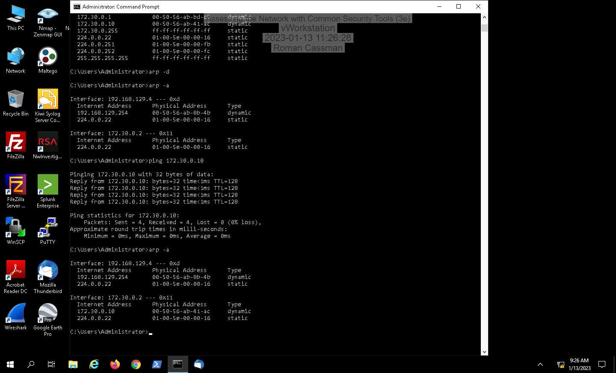

Question 19.

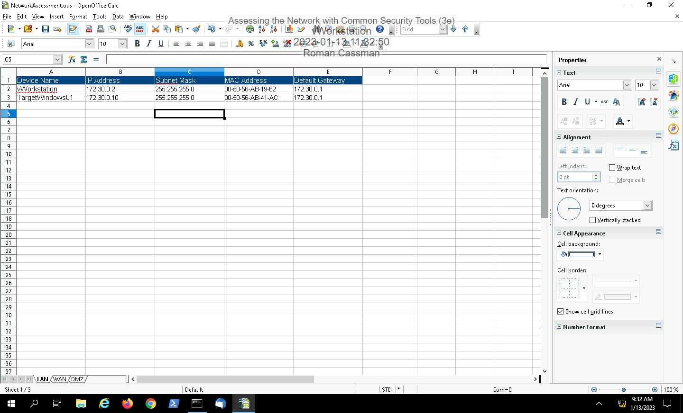

Part 2:

Question 9.

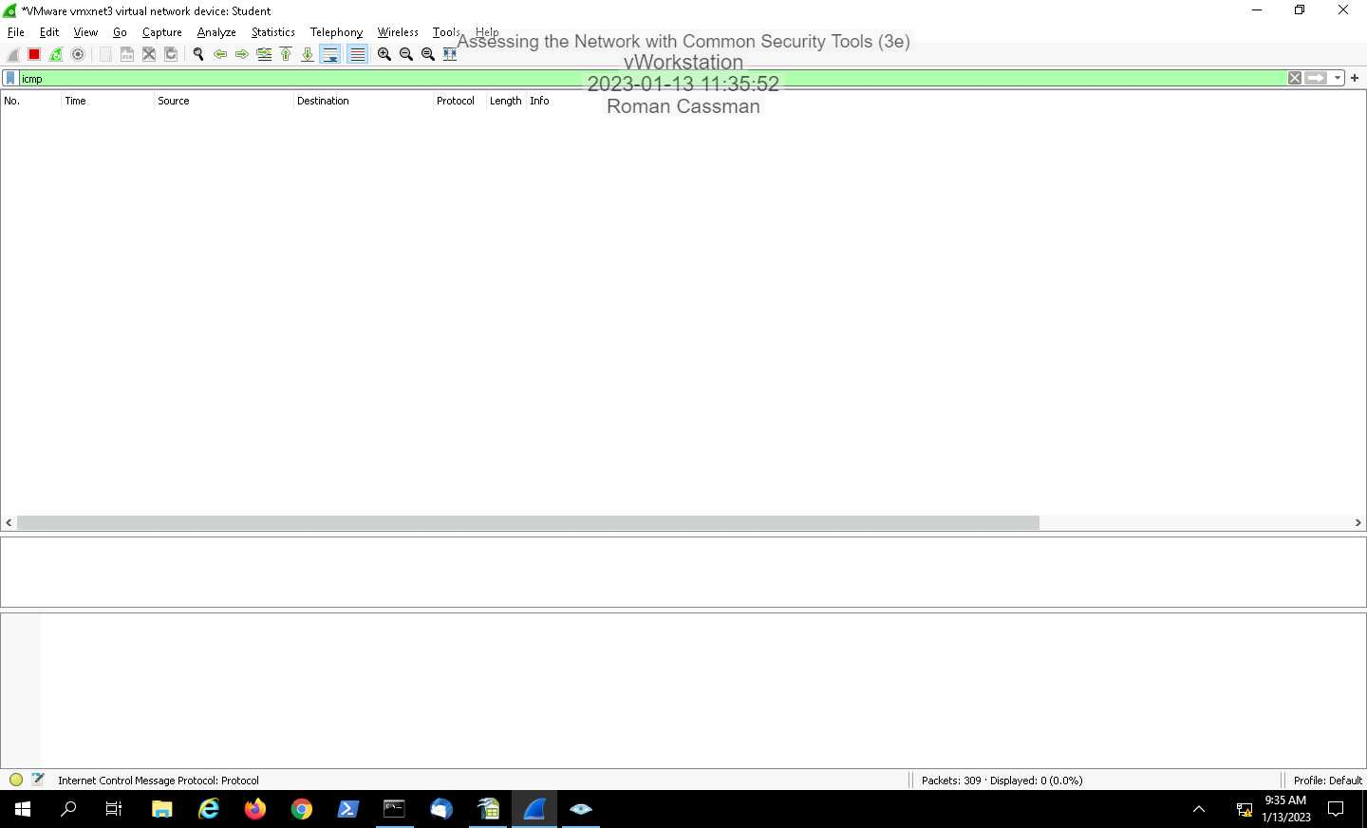

Question 12.

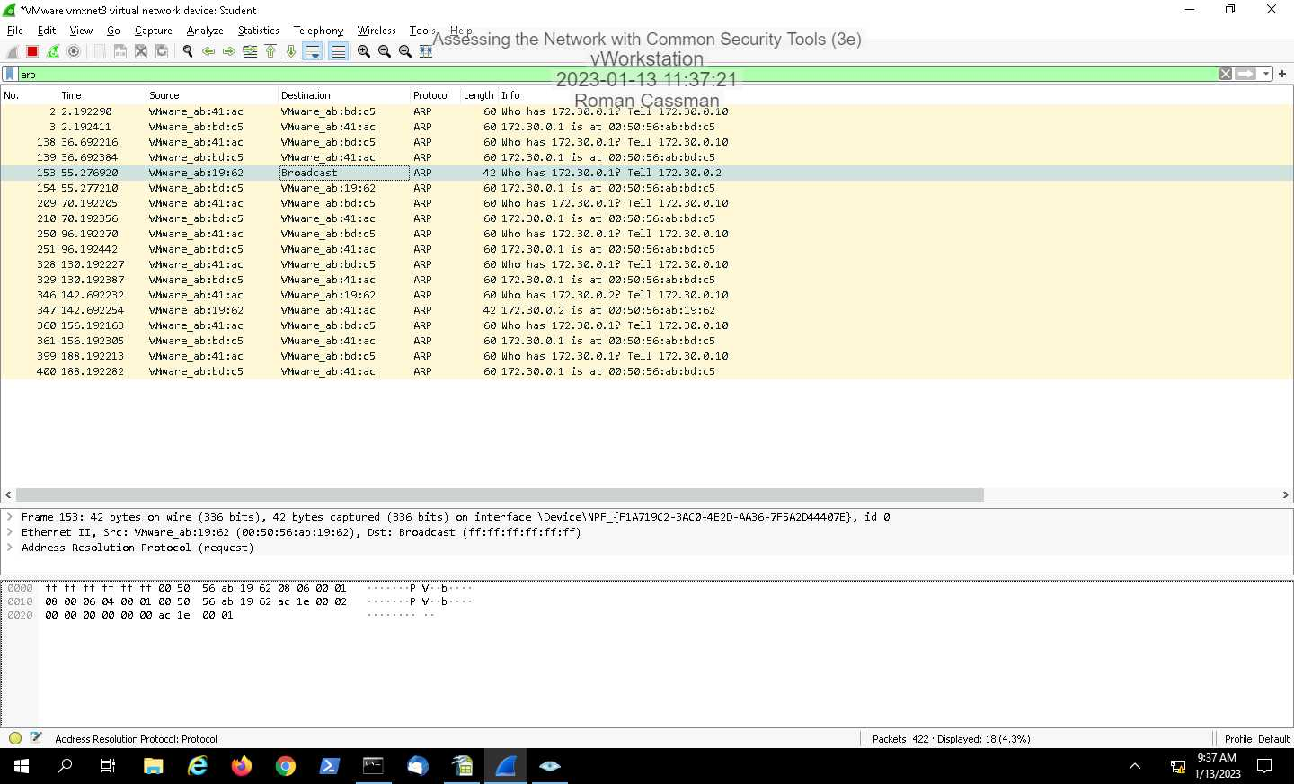

Question 18.

The results were similar where ICMP didn't show anything, but ARP did.

24.

The results were different. This time the ICMP showed results as well as ARP.

ICMP results

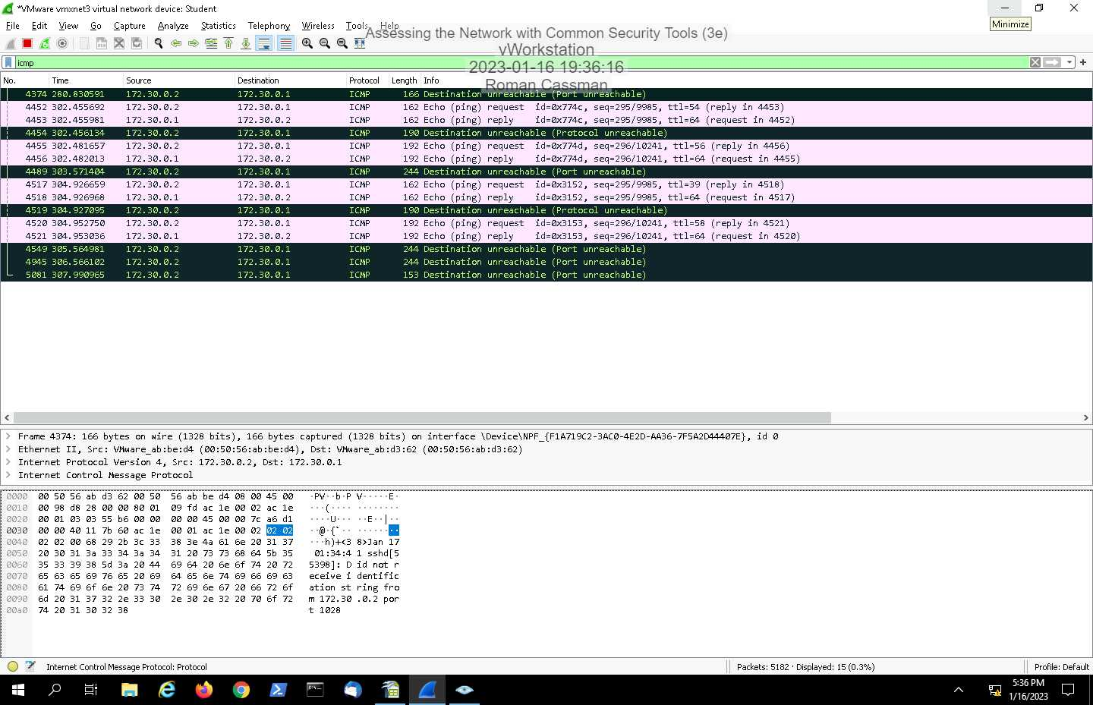

ARP Results

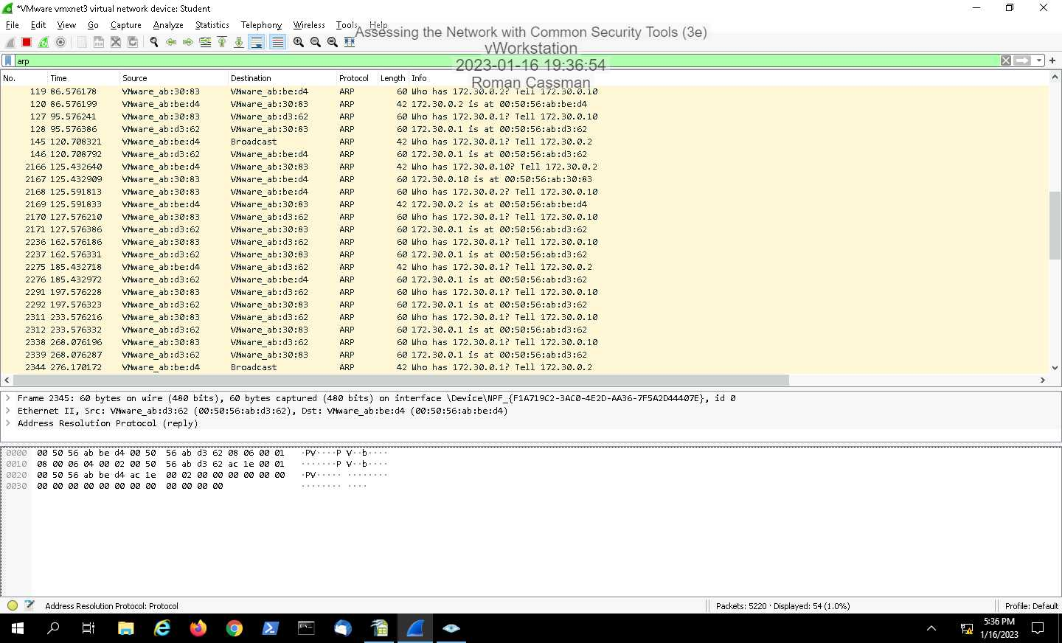

28.

